CSV upload guidelines:

Initial upload. (on create project)

1. The file cannot be empty
2. The file must contain at least 2 columns
3. The file must contain at least 2 subjects
4. The first Row must be column headers(Criteria names)
5. One of the columns must be a unique identifier and have a unique value for every subject.
6. The unique identifier column must be the first column.
7. Each student must contain a value for each column.
8. Any number of columns can be present
9. Any number of subjects can be present

Minimal correct initial upload:

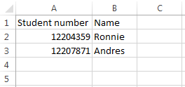

Correct initial upload:

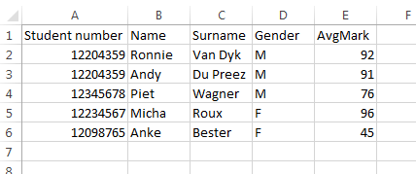

Incorrect uploads:

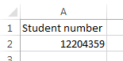 (Rules 2, 3 broken)

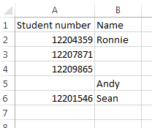 (Rule 7 broken)

Additional upload (Add criteria or add subjects)

Initial upload rules 1,2,4,5,6,7,8,9 applies to any additional uploads.

HINTS:

1. Download a csv containing all subjects in the current set.
2. Add additional criteria or subjects to that file.
3. Subjects can also be edited and the changed values will overwrite the current values in the set.
4. Do not delete a subject from the file(Deleting subjects can be done online in the subjects table)

Rules:

Adding Criteria

1. First column of the file must contain unique identifiers, one for each subject currently existing in the set. (Omitting one identifier will result in error)
2. New criteria can be added in the column next to the identifiers. (Omitting the rest of the columns currently in the set. This is to make it possible for the user to add criteria by using only a list of all the subject’s unique identifiers. NB no additional subjects can be added in this way. See ‘Adding Criteria and Subjects’ section. More than one new criteria can also be added in this way.)

Correct add criteria upload:

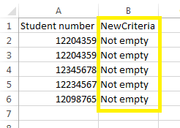

Adding subjects

1. For only adding new subjects use the whole subject set. (can be downloaded from the team setup page) and append new students at the end of the file.
2. New subjects must have a value for each criteria currently in the set.
3. New subjects must have an identifier unique from any existing subjects in the set.

Correct add subjects upload:

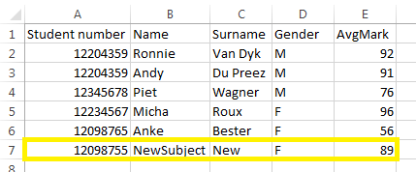

Adding Criteria and Subjects (Growing the set horizontally and vertically)

1. For only adding new criteria and subjects use the whole subject set. (can be downloaded from the team setup page)
2. Append new criteria in the first available column next to the last criteria in the current set.
3. Append subjects to the end of the file after the last subject in the current set.
4. New students must have values for each criteria in the current set, even newly added criteria.

Correct add criteria and subjects upload:

